The 9th International Conference on Sustainable Economic Development and Business Management
(SEDBM2026)

 | 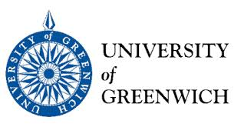 | 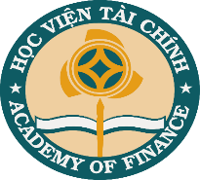 |  | 12th – 14th, November 2026  Hanoi,| Vietnam
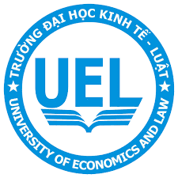 | 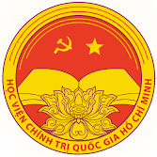 |  | 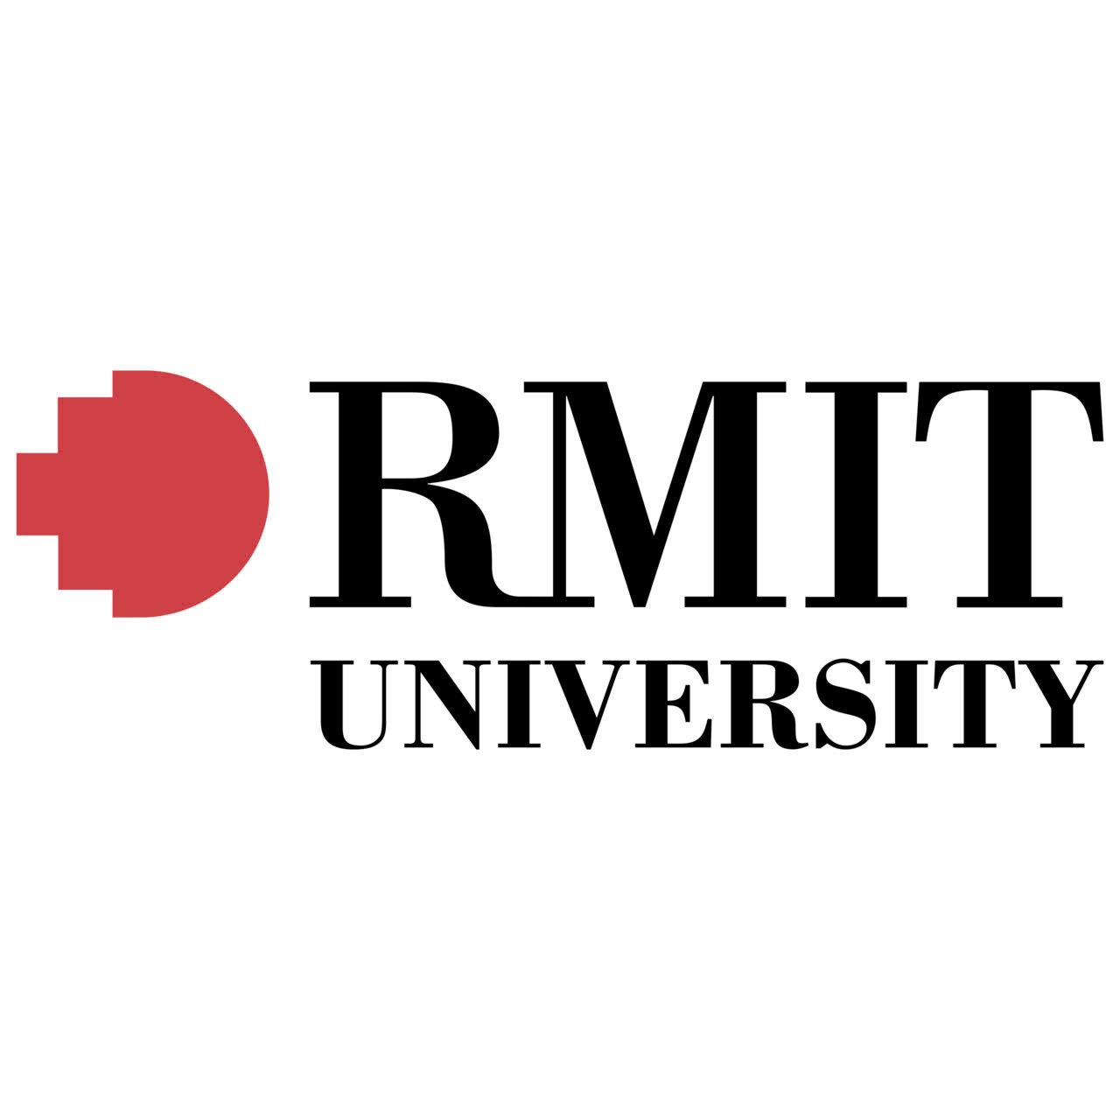 | Logo của Hội thảo

SUBMIT PAPER

Home | History  - SEDBM 2018  - SEDBM 2019  - SEDBM 2020  - SEDBM 2021  - SEDBM 2022  - SEDBM 2023  - SEDBM 2024  - SEDBM 2025 | Keynote Speakers | Scientific Conmitee | Call for paper | Submission and Registration  - Submission guideline  - Registration  - Importance date | Publication  - Journals  - Proceedings | Programme | Venue  - Conference  - Venue  - Tourism  - Visa  - Procedure  - Visit Hanoi  - Travel and  - Accomodation | Contact us

HOME
The International Conference on
Sustainable Economic Development and Business Management (SEDBM2026) is jointly organized by the Academy of Finance, Knowledge Bridge Research Institute, RMIT University, Nottingham Trent University, Institute of Economics – Ho Chi Minh National Academy of Politics, University of Economics and Law – Vietnam National University, Ho Chi Minh City and University of Greenwich

The conference brings together world-leading experts in finance, accounting, auditing, economic and business administration. It serves as a hub for researchers, practitioners and policymakers to connect, share insights and exchange ideas. SEDBM2026 offers abundant networking opportunities, allowing participants to engage with top scholars and professionals from both academia and industry. The event also provides a vibrant platform for stimulating discussions on contemporary research topics and practical applications.
About the organizer: The Academy of Finance
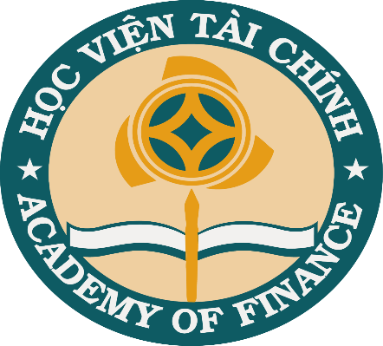

Founded in 1963, the Academy of Finance (AOF) is one of Vietnam’s leading public institutions in higher education and research in economics, finance, accounting, business administration, and related disciplines. With a strong legacy of academic excellence and innovation, AOF has trained over 100,000 bachelors’ graduates, 10,000 masters’ degree holders, and 700 PhD holders, many of whom hold key positions in government, ministries, and businesses across Vietnam.
The Academy offers a wide range of undergraduate and postgraduate programs in both full-time and part-time formats, including international and bilingual pathways. AOF is committed to fostering a dynamic learning environment that integrates a solid theoretical foundation with practical applications, aligned with global standards and the evolving demands of the digital economy.

As part of its strategic vision, AOF prioritizes internationalization, research advancement, and digital transformation. It actively engages in research, policy consultation, and capacity-building initiatives for the Ministry of Finance and other governmental agencies. With expanding collaboration with global universities and professional bodies, AOF aspires to become a regional hub of academic and professional excellence in finance and economics.
The conference is organized in association with
 |  | 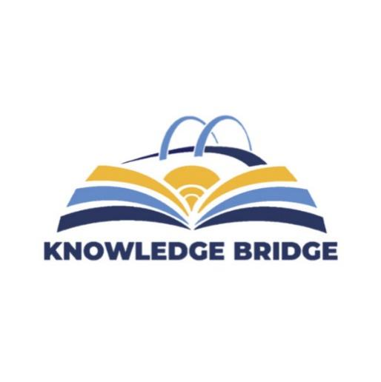
 |  | 

Contact us
aof_sedbm@hvtc.edu.vn
Nguyen Minh Thanh, Assoc. Prof, Academy of Finance, Vietnam, (84)(912)69-1315
Nguyen Thi Thuy Nga, PhD, Academy of Finance, Vietnam, (84)(869)98-7986

HISTORY
(Link đến các hội thảo trong quá khứ)
- SEDBM 2018
- SEDBM 2019
- SEDBM 2020
- SEDBM 2021
- SEDBM 2022
- SEDBM 2023
- SEDBM 2024
- SEDBM 2025

KEYNOTE SPEAKERS
1. Professor Bohui ZHANG

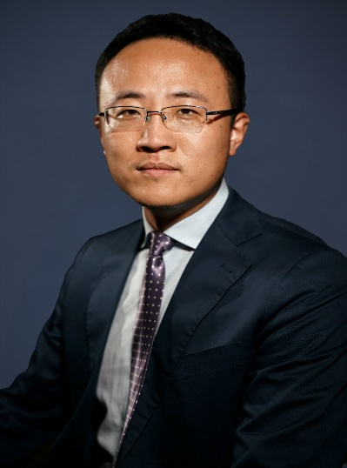

Bohui Zhang is the Executive Dean of School of Management and Economics at The Chinese University of Hong Kong, Shenzhen, the Associate Director of Shenzhen Institute of Data Economy, the Director of the Center for FinTech and Social Finance (SFI), SFI Chair Professor.
He was also the professor of finance at UNSW Business School, UNSW Sydney, and the associate director of the Institute of Global Finance (IGF). He studies FinTech, the media, Chinese capital market, and international capital markets. His papers have been accepted for publication in the global top-tier finance, accounting, and business journals such as the Review of Financial Studies, Journal of Financial Economics, Journal of Accounting Research, Management Science, Journal of Financial Quantitative and Analysis, Journal of International Business Studies, Review of Finance, Journal of Banking and Finance, Journal of Corporate Finance, Journal of Financial Markets, and Journal of International Money and Finance.
He has also been awarded with research grants from Australian Research Council, the Centre for International Finance and Regulation, Australian School of Business, National Natural Science Foundation of China, and best paper prizes from MIT Asia Conference in Accounting, the Annual Conference on Asia-Pacific Financial Markets of the Korean Securities Association, the Chinese Finance Association Best Paper Symposium, the China Finance Annual Meeting, the Asian Finance Association Conference, China International Conference in Finance, and the Northern Finance Association Conference.

2. Professor Tam Nguyen
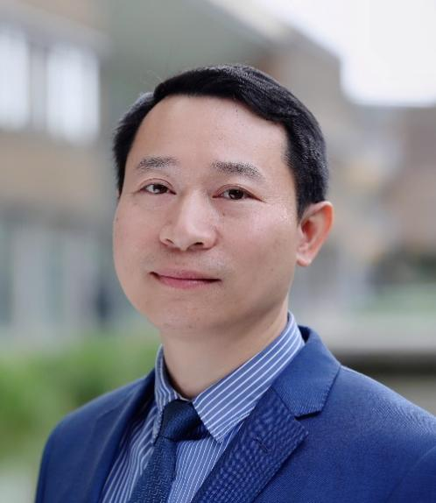

Professor Tam Nguyen (PhD, FCCA, CPA Australia, PGCHE, FHEA) is a Professor of Accounting and Finance at Nottingham Business School, Nottingham Trent University, UK. He has been qualified as a chartered accountant with several professional accountancy bodies, including ACCA, UK; CPA Australia; and CPA Vietnam. He is also a Fellow of the Higher Education Academy. His research interests cover a wide range of topics of financial reporting, corporate governance, corporate social responsibility, sustainability, and climate finance.
His research has been featured in different internationally excellent research journals, such as Energy Economics, Corporate Governance: An International Review, Business and Society, Financial Accountability and Management, International Review of Financial Analysis, Accounting Forum, Business Strategy and the Environment, and Review of Quantitative Finance and Accounting.
Professor Nguyen is currently Associate Editor at (i) Journal of Applied Accounting Research, (ii) Accounting Research Journal and (iii) Journal of Financial Reporting and Accounting. He is a Co-Chair of Corporate Governance-SIG, the British Academy of Management (BAM) and an academic advisor for the Vietnam Institute of Directors (VIOD)

3. Professor Petros Ieromonachou
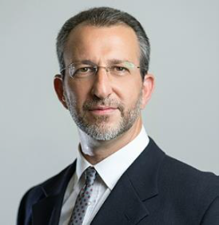

Professor Ieromonachou is the Associate Dean for Research and Knowledge Exchange at the University of Greenwich Business School, where he provides strategic leadership for research, REF planning, external income growth, and impact generation. He aligns school activities with the University’s Strategy 2030 and has strengthened research culture, collaboration, and funding. Under his direction, the School has achieved notable increases in external research income, REF readiness, and high-quality impact case studies. Previously, he led the Department of Systems Management and Strategy (2012–2020) and managed large academic teams across campuses and international partners. He founded the Connected Cities Research Group and co-directs the Networks and Urban Systems Centre of Excellence, contributing to major projects in the UK, Europe, and Asia. His research focuses on urban business ecosystems, sociotechnical transitions, and operations strategy, with extensive publications and invited talks worldwide. Holding a personal Chair since 2018, he has authored over 30 peer-reviewed papers and led externally funded projects totaling £12.49 million, including over £5 million for the University of Greenwich. His ongoing work continues to support the University’s strategic goals and REF2029 planning.

SCIENTIFIC COMMITTEE
General chair
Nguyen Dao Tung, Assoc. Prof, President of Academy of Finance, Vietnam
Tam Nguyen, Prof, Nottingham Trent University
Nguyen Manh Thieu, Assoc. Prof, Vice President of Academy of Finance, Vietnam
Duc Phan, PhD, Knowledge Bridge Research Institute, RMIT University, Australia

Program Chair
Tam Nguyen, Prof, Nottingham Trent University
Mai Ngoc Anh, Assoc. Prof, PhD, Academy of Finance, Vietnam
Vu Van Ninh, Assoc. Prof, PhD, Academy of Finance, Vietnam
Vu Duy Nguyen, Assoc. Prof, PhD, Academy of Finance, Vietnam
Nguyen Le Cuong, Assoc. Prof, PhD, Academy of Finance, Vietnam
Ngo Thanh Hoang, Assoc. Prof, PhD, Academy of Finance, Vietnam
Chuc Anh Tu, Prof, PhD, Academy of Finance, Vietnam
Nguyen Thi Hong Van, Assoc. Prof, PhD, Academy of Finance, Vietnam
Nguyen Minh Thanh, Assoc. Prof, PhD, Academy of Finance, Vietnam
Nguyen Truong Giang, PhD, Academy of Finance, Vietnam
Nguyen Thi Thuy Dung, PhD, Academy of Finance, Vietnam
Pham Thanh Hoa, Assoc, Prof, PhD, Academy of Finance, Vietnam

Steering committee
Mai Ngoc Anh, Assoc. Prof, PhD, Academy of Finance, Vietnam
Ngo Thanh Hoang, Assoc. Prof, PhD, Academy of Finance, Vietnam
Nguyen Thi Hong Van, Assoc. Prof, PhD, Academy of Finance, Vietnam
Nguyen Anh Quang, PhD, Academy of Finance, Vietnam

Web and Social Media Team
Nguyen Minh Thanh, Assoc. Prof, PhD, Academy of Finance, Vietnam
Ngo Van Lương, PhD, Academy of Finance, Vietnam

CALL FOR PAPER
SEDBM - 2026 solicits high quality, unpublished and authentic contributions that discusses innovative research ideas and innovation and research challenges.
The major focus of our conference are:
• To share a collaborative knowledge platform among researchers from diversified areas of sustainable economic development, business management, finance and accounting, from different corners of the world
• To promote a partnership among academia and industry
• To publicize innovative research ideas and recent trends in sustainable economic development, business management, finance and accounting research
• To provide a wide platform to the budding researchers for sharing their ideas in front of eminent speakers from highly renowned organizations
Some of our popular areas, not limited to, but as follows are:

SUSTAINABLE ECONOMIC DEVELOPMENT
- Opportunities and Challenges in Global Frontier Markets
- National economic growth models
- Investment and Business Environment.
- Sustainable Development and the Industrial Revolution 4.0
- Sharing Economy, Digital Economy, Night-time Economy, Circular Economy
FINANCIAL MANAGEMENT
- Build your Business Resilience in the time of crisis
- Financial Markets- Growth and Opportunities
- International Financial Economics
- Financial Literacy
- Financial management in the digital era
- Fintech; Green Financing

ACCOUNTING AND AUDTING
- Financial & Green Accounting
- Management & sustainability Accounting
- Corporate Social Responsibility Accounting
- Information Technology Audit
- Audit
- Business Data Analytics
- Accounting & Audit in The Industrial Revolution 4.0.
- Digital Transformation in Accounting & Audit

HUMAN RESOURCE MANAGEMENT
- Strategic talent acquisition and retention
- Talent, technology and ideas
- Rethink HR
- Culture in the new normal/ Navigating the new normal

MARKETING MANAGEMENT
- Green Marketing
- Luxury Marketing
- Social Media Marketing
- Digital marketing

SUBMISSION and REGISTRATION

Submission guideline
A paper refers to a fully developed manuscript on a scholarly topic. The paper's format follows the guidelines set by Springer Nature Publishing: https://beta.springernature.com/pre-submission/submission-guidelines
Authors are invited to submit their manuscripts in English before the deadline via CMT Platform – Link “Submit Papers” on this website (Manuscripts should be sent via email: aof_sedbm@hvtc.edu.vn for backup purpose)

Registration
SEDBM 2026 CONFERENCE REGISTRATION FEE
Registration Type | Amount (VND)
PhD Candidate Category: | 2.000.000 VND
Faculty Category | 3.000.000 VND

SEDBM 2025 Registration Policy:
The registration fees apply for a maximum of 12 pages only, additional pages shall be charge extra ( 500.000 VND) per page up to a maximum of 15 pages only.
In case of co-author want to attend the conference than its advisable to register well in advance instead of the spot registration request.
Refund Policy:
In case that the author after the registration due to some reason wants to cancel the registration, in such cases, the conference will be able to refund only 50% of the fees only. The last date of application of registration cancellation request submission is October 20th, 2026.
Conference Fee Includes
- Admission to Science
- Sessions
- Coffee Breaks
- Lunches
- Gala Dinner
- A Certificate of Attendance.

Important Date
Full-text Paper Submission: Deadline August 20th, 2026
Notification of Acceptance/Rejection September 20th, 2026
Registration: October 20th, 2026
Conference Dates: November 12th-14th, 2026

PUBLICATION

Journals
1. Journal of Finance & Accounting Research
In consultation with the Editor-in-Chief of Journal of Finance & Accounting Research authors of best conference papers will be invited to submit their papers to a regular issue of the Journals.

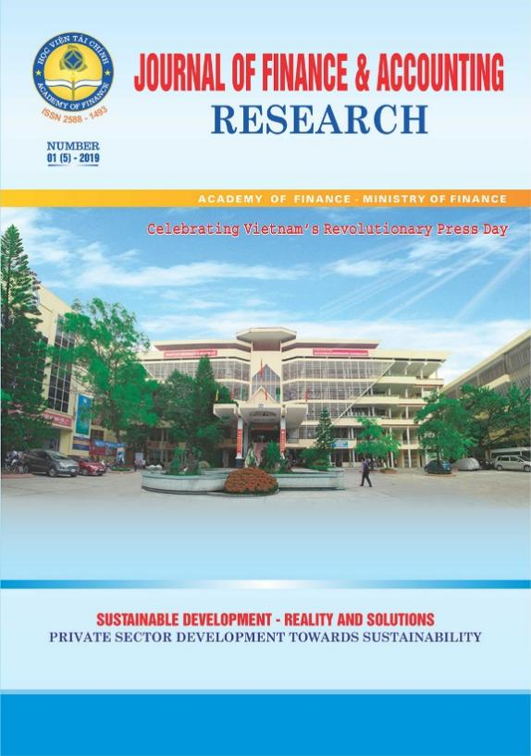

Proceedings
Papers that are accepted will be included in the conference proceedings, to be published by a domestic or international publisher.

PROGRAMME
Updating

VENUE

Conference Venue
Academy of Finance
58, Le Van Hien, Dong Ngac, Hanoi or Hoa Lac High – Tech industry Campus
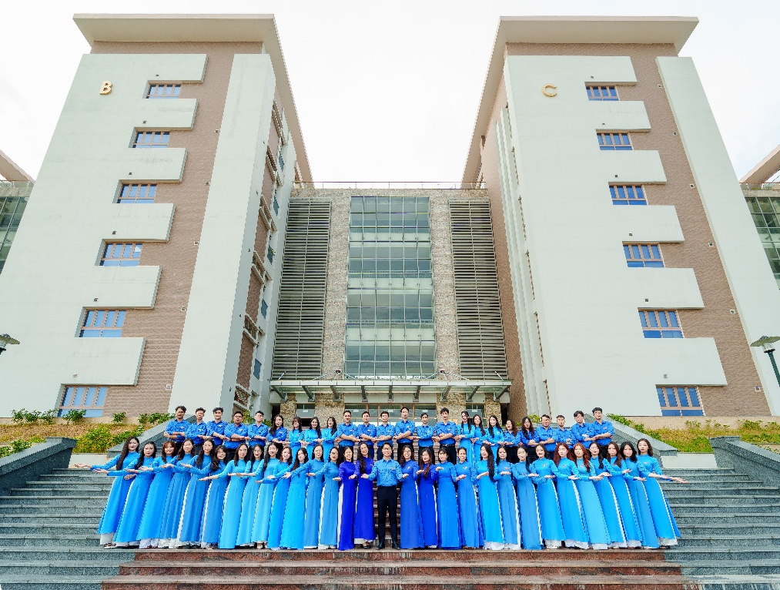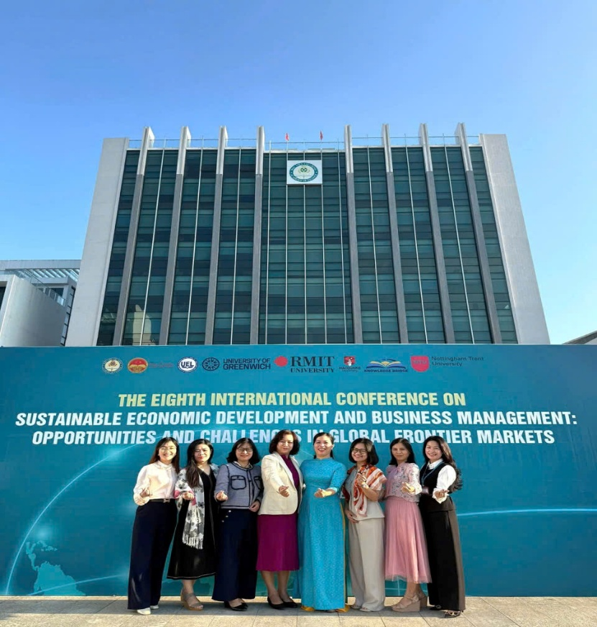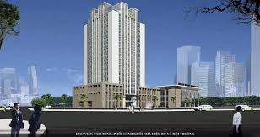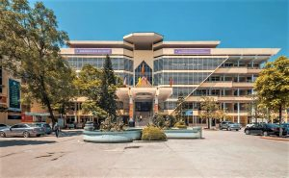

Tourism
1. Ha Long Bay

A UNESCO World Heritage Site, beautiful Halong Bay is one of Vietnam’s most popular tourist attractions, famous for its thousands of limestone islets of all different shapes and sizes rising up from the bay’s emerald waters.
Without a doubt, Halong Bay should be on every traveler’s bucket list who enjoys gorgeous natural seascapes. Navigating a Halong Bay trip usually involves two steps: Firstly, deciding how to travel from Hanoi to Halong Bay, and secondly, choosing from between hundreds of boats that ply the waters of Halong Bay on day, overnight and multi-day cruises.
https://whc.unesco.org/en/list/672/
2. Ninh Binh
Far too few travellers make it to Ninh Binh, a mesmerizing area known locally as ‘Halong Bay on Land’ thanks to its magical riverine landscape, with sheer limestone mountains rising up from the paddies. The best way to get a sense of this UNESCO-protected site is by taking a paddleboat tour along its shimmering rivers, and climbing to the top of its fabled peaks.

https://whc.unesco.org/en/list/1438/

3. Duong Lam ancient Village
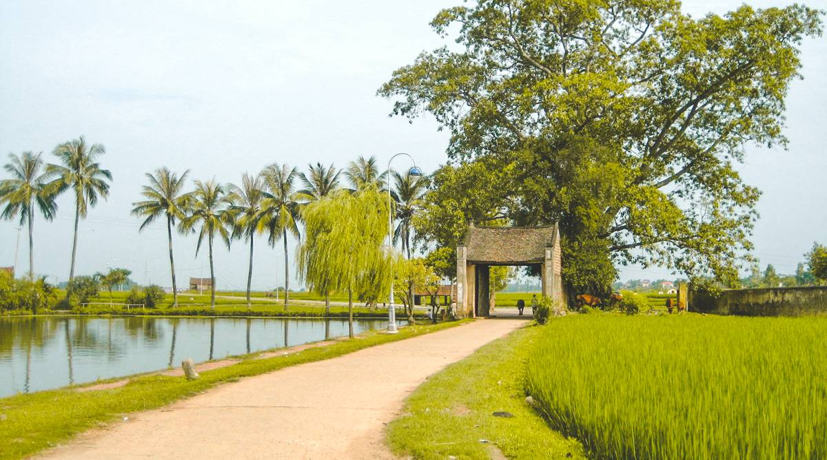
Đường Lâm Ancient Village is a well-preserved traditional village located about 50 kilometers west of Hanoi, Vietnam. It is famous for its ancient houses made of laterite and its unique architecture reflecting northern Vietnamese rural culture. The village is often called a “living museum” of Vietnamese history and heritage. It is also the birthplace of two national heroes: Phùng Hưng and Ngô Quyền. Visitors come to Đường Lâm to explore its historical charm, peaceful scenery, and cultural richness.

Visa Procedure
Updating

Visit Hanoi
The Literature Temple
The Temple of Literature is often cited as one of Hanoi’s most picturesque tourist attractions. Originally built as a university in 1070 dedicated to Confucius, scholars and sages, the building is extremely well preserved and is a superb example of traditional-style Vietnamese architecture.
This ancient site offers a lake of literature, the Well of Heavenly Clarity, turtle steles, pavilions, courtyards and passageways that were once used by royalty. Visiting the Temple of Literature you will discover historic buildings from the Ly and Tran dynasties in a revered place that has seen thousands of doctors’ graduate in what has now become a memorial to education and literature.
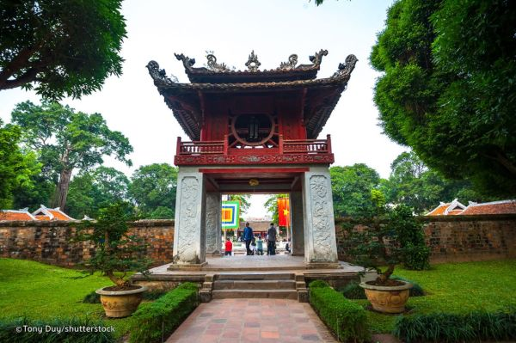
Hanoi Old Quarter
Located in the middle of Hanoi, a rapidly developing city where changes take place every hour, Hanoi Old Quarter with its old-styled narrow streets full of antique brick houses seems to nostalgically resist the flow of time while still actively trying to adapt to the dynamic atmosphere of the modern city.
Once a bustling area where merchants and artisans gathered to sell their products, Ha Noi Old Quarter consists of many small, meandering streets, each bears the name of the goods that was specifically traded there such as Hang Bac (Silver Product), Hang Ma (Paper Product), Hang Go (Wood Product), just to name a few.
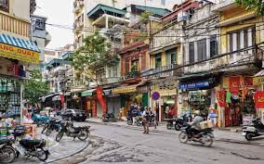
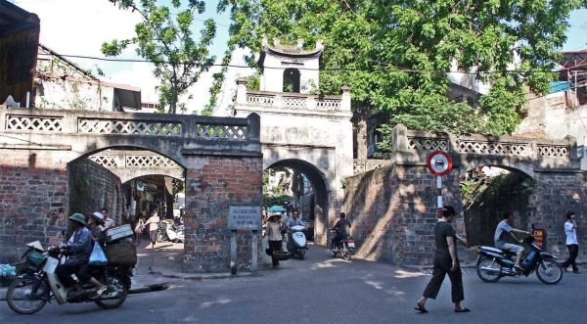
Hoan Kiem Lake and Ngoc Son Temple
Hoan Kiem Lake in Hanoi attracts tourists and locals looking to get away from the noise and frenetic pace of the city. Peaceful and quiet, the lake surrounds Ngoc Son Temple, an 18th century pagoda sitting in on a small island that’s accessible via an ornate wooden bridge. Inside the temple are several altars dedicated to military leader Tran Hung Dao, large bronze bust, some ancient artefacts including ceramics, and a preserved specimen of a giant turtle found in the lake weighting 250kg.
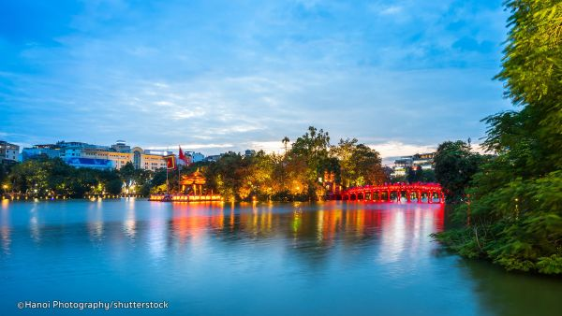

CONTACT US
Email: aof_sedbm@hvtc.edu.vn
Nguyen Minh Thanh, Assoc. Prof, the Academy of Finance, Vietnam, (84)(91)269-1315
Nguyen Thi Thuy Nga, PhD, the Academy of Finance, Vietnam, (84)(86)998-7986

